**Background**

Your client, PetsCare, is a local clinic that takes care of pets, including pet wellness and vaccination, medical services, surgery including spay and neuter, dental cleaning and treatment, grooming, etc. PetsCare has served the community for more than 20 years, and has been successful in the business.

Recently, the current owner, Claire, who is the daughter of the founder of PetsCare, realized that the old file system solution is very inefficient. She and her team have to spend lots of time taking records, querying for information, and maintaining the data. She decided to turn to you, for a Relational Database Management System.

PetsCare wants to record information about customers, pets, staff, visits. Claire will be available to meet via Zoom tomorrow to discuss details. You should prepare questions for building the DBMS.

**Task:** What questions should you ask during the meeting?

1. How are your records currently stored?
2. Have the methods changed over time?
3. How do you currently access/sort/retrieve these files?
4. Have you tried any other methods or systems?
5. How much data do you have?
6. What are mandatory types of information you record? What is optional?
7. What are the most common types of information you need to retrieve?
8. What are some key concepts that may help in finding that information quickly for you?
9. How many customers do you have per week on average?
10. How much data do you record for each customer?
11. How many staff do you have?
12. How far in the past do you wish to retain your records of customers/pets/staff/care?
13. Are there any new types of information you would like to retain? E.g. scans, notes, pictures, etc
14. What are some absolute needs for this project?
15. What are some more lofty desires for this project?
16. What is your expected date of implementation?
17. Will you require training for you/your staff for the new system?
18. What is your budgeted range of expense for this project?

**What are the Basic Entity Relationships Involved?**

**Outline**

* Customers: CustomerID, FirstName, LastName, Address, Email, Phone, DoB, PaymentInfo, JoinDate. CustomerID is the identifier.
* Pets: CustomerID, Pet#, NickName, Address, Email, Phone, Category, Species/Breed, Species/Breed Description, Gender, DoB, Notes. CustomerID and Pet# together as the identifier.
* Staff: EmployeeID, FirstName, LastName, SSN, Address, Email, Phone, DoB. EmployeeID is the identifier.
* Visit: VisitID, Date, Time, Customer, Pet, ServiceID, ServiceName, ServicePrice, ServiceDescription, Staff, Bill, Paid. VisitID is the identifier.

Their relationships are:

* A customer may have one or more (zero or more) pets; A pet must belong to one and only one (exactly one) customer.
* A staff may treat one or more pets (zero or more); and A pet may be familiar with one or more (zero or more) staff.
* A customer may have one or more (zero or more) visits; and each visit must be done by one and only one (exactly one) customer.
* A pet may have one or more (zero or more) visits; and each visit may involve one (zero or one) pet.
* A staff must be in charge of one or more (one or more) visits; and a visit must be charged by one and only one (exactly one) staff.
* A customer may be referred by one (zero or one) customer; and a customer may refer one or more (one or more) customers.
* A staff must have one and only one (exactly one) supervisor; A staff may supervise one or more (zero or more) staff.

**Create Relational Diagram**

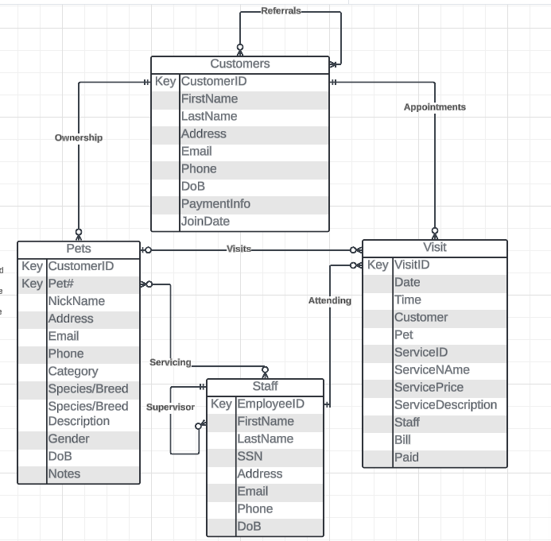

**Here is the relational model converted from the ERD:**

* Customers (CustomerID, FirstName, LastName, Address, Email, Phone, DoB, PaymentInfo, JoinDate, ReferredByCustomerID(fk)).
* Pets (CustomerID(fk), Pet#, NickName, Address, Email, Phone, Category, Species/Breed, Species/Breed Description, Gender, DoB, Notes).
* Staff (EmployeeID, FirstName, LastName, SSN, Address, Email, Phone, DoB, SupervisorID(fk)).
* Visit (VisitID, Date, Time, CustomerID(fk), Pet(fk), ServiceID, ServiceName, ServicePrice, ServiceDescription, EmployeeID(fk), Bill, Paid).
* Pets_Staff(CustomerID(fk), Pet#(fk),EmployeeID(fk))

**Normalize the Relational Model to 3NF**

Before normalization, you should ask Claire about the Functional Dependencies of the relations. Here is what you got from her:

* Customers (CustomerID, FirstName, LastName, Address, Email, Phone, DoB, PaymentInfo, JoinDate, ReferredByCustomerID(fk)).
  + FD1: CustomerID → FirstName, LastName, Address, Email, Phone, DoB, PaymentInfo, JoinDate, ReferredByCustomerID
* Pets (CustomerID(fk), Pet#, NickName, Address, Email, Phone, Category, Species/Breed, Species/Breed Description, Gender, DoB, Notes).
  + FD1: CustomerID, Pet# → NickName, Address, Email, Phone, Category, Species/Breed, Species/Breed Description, Gender, DoB, Notes.
  + FD2: CustomerID → Address, Email, Phone
  + FD3: Species/Breed → Species/Breed Description
* Staff (EmployeeID, FirstName, LastName, SSN, Address, Email, Phone, DoB, SupervisorID(fk)).
  + FD1: EmployeeID  → FirstName, LastName, SSN, Address, Email, Phone, DoB, SupervisorID
* Visit (VisitID, Date, Time, CustomerID(fk), Pet(fk), ServiceID, ServiceName, ServicePrice, ServiceDescription, EmployeeID(fk), Bill, Paid).
  + FD1: VisitID → Date, Time, CustomerID, Pet, ServiceID, ServiceName, ServicePrice, ServiceDescription, EmployeeID, Bill, Paid
  + FD2: ServiceID  → ServiceName, ServicePrice, ServiceDescription.
* Pets_Staff(CustomerID(fk), Pet#(fk),EmployeeID(fk))
  + There is no non-primary-key attribute.

**3NF FORM**

* Customers (CustomerID, FirstName, LastName, Address, Email, Phone, DoB, PaymentInfo, JoinDate, ReferredByCustomerID(fk))
* Staff (EmployeeID, FirstName, LastName, SSN, Address, Email, Phone, DoB, SupervisorID(fk)).
* Pets_Staff(CustomerID(fk), Pet#(fk),EmployeeID(fk))
* Species (Species/Breed, Species/Breed Description)
* Pets (CustomerID(fk), Pet#, NickName, Category, Species/Breed(fk), Gender, DoB, Notes).
* Service (ServiceID, ServiceName, ServicePrice, ServiceDescription)
* Visit (VisitID, Date, Time, CustomerID(fk), Pet(fk), ServiceID(fk), EmployeeID(fk), Bill, Paid).